

Data Structures & Algorithms Lab 1

**Table of Contents**

Overview 1

Objective 1

Output 2

Files 2

Submissions 2

# Overview

There are a number of factors that can cause a program to fail. Compiler errors, linker errors, memory leaks, and logic errors, just to name a few. As a developer, you will encounter these often, so it is important to know how to correct them.

Make sure that you use the tools available to you (debugger, internet, etc.) to help you make the necessary corrections.

# Objective

This lab project will have you working with a broken project that has a number of issues that you will need to correct to get the desired output.

**Note – Due to the nature of this lab, you will not be able to get direct assistance on how to fix the errors, but we will help you in learning better use of the tools available.**

# Output

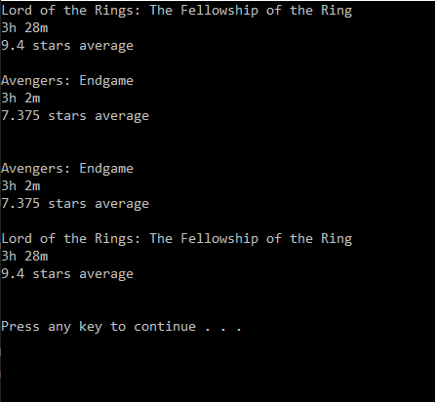

# Grading

**This is a pass/fail assignment.**

|  |  |
| --- | --- |
| Compiling program with all logic errors corrected | 80 |
| No memory leaks | 20 |

# Files

You may need to make changes in any of the files in order to fix the errors presented.

# Submissions

Zip the three code files (main.cpp, Movie.h, and Movie.cpp) and submit them via FSO.